MST (worksheet 1)

Trees

### Draw either a tree with the given specification or explain why no such graph exists:

* 1. Tree, four vertices, three edges
  2. Tree, nine vertices, nine edges

### How many edges does a tree with “n” number of vertices have?

### What happens if you delete an edge in a tree?

### In a tree, can vertices be connected by more than one path?

### What happens if you add an edge to a tree?

### If the total degree of a graph is the sum of all the degrees of its vertices, what is the total degree if a tree with ‘n’ vertices?

MST (worksheet 2)

Minimum Spanning Trees*

Once upon a time there was a city that had no roads. Getting around the city was particularly difficult after rainstorms because the ground became very muddy—cars got stuck in the mud and people got their boots dirty. The mayor of the city decided that some of the streets must be paved, but didn’t want to spend more money than necessary because the city also wanted to build a swimming pool. The mayor therefore specified two conditions:

1. Enough streets must be paved so that it is possible for everyone to travel from their house to anyone else’s house only along paved roads, and
2. The paving should cost as little as possible.

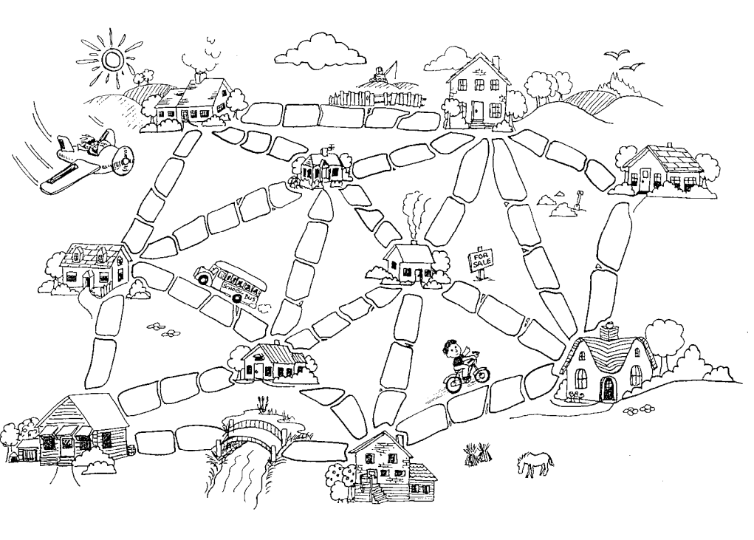Here is the layout of the city. The number of paving stones between each house represents the cost of paving that route. Find the best route that connects all the houses, but uses as few counters (paving stones) as possible. What strategies did you use to solve the problem?

* This activity has been adapted from “Muddy City” in CS Unplugged (CC BY-NC-SA 3.0)  
 <http://csunplugged.org/minimal-spanning-trees/>

How about this one that we saw in the slides? It is represented as a graph!

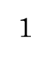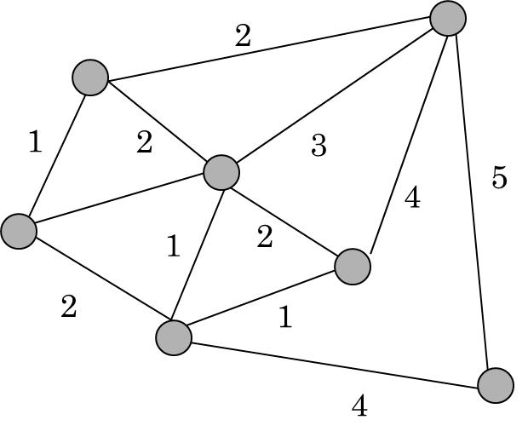MINUMUM WEIGHT =

Could you write down a general strategy to solve the problem that works in every case? Would you need more examples to test it? Turn the page!

MST (worksheet 3)

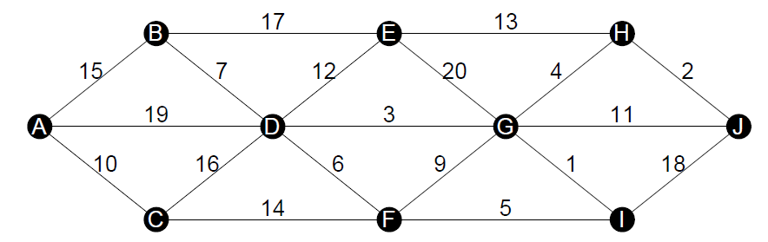Minimum Spanning Trees - Prim

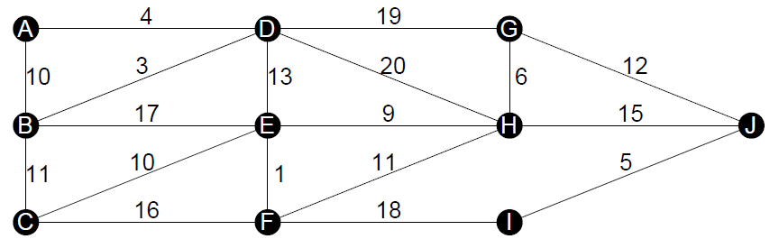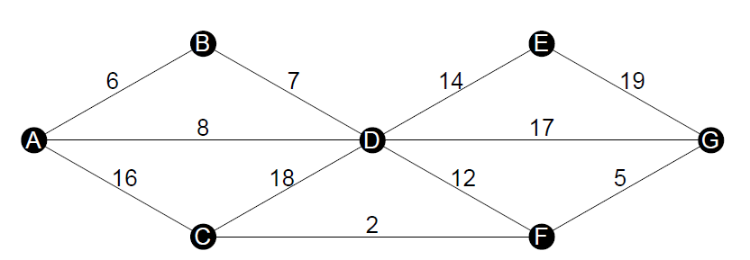

MST (worksheet 4)

Minimum Spanning Trees - Kruskal

